**FORMAN CHRISTIAN COLLEGE (A CHARTERED UNIVERSITY)**

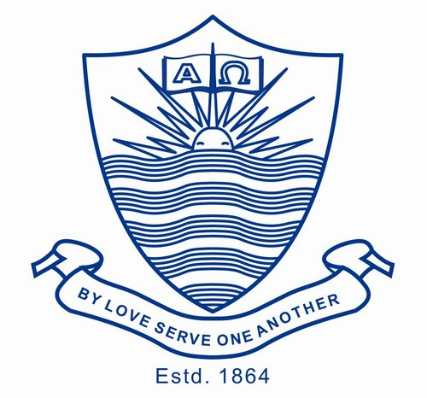

**Mobile App Development CSCS 468**

**FALL 2023**

**Project Proposal**

**Sheikh Abdul Wahhab 231524911**

**Sarmad Sabir 231523180**

**Project Overview:**

**The primary goal of this project is to develop a user-friendly mobile application that enables individuals to monitor their heart rate in real-time. The app will feature a simple and intuitive user interface, making it accessible to a wide range of users, including individuals with minimal technical expertise.**

**Key Features:**

**1. Real-time Heart Rate Monitoring: The app will use data extracted from a cloud database to be translated into a graph that tells the patient’s heartbeat. This feature could be improved upon if connected to a sensor attached to the patient, but for implementation basis we will use dummy data.**

**2. User Profiles: Users can create profiles to track their heart rate history over time and set personalized health goals.**

**3. Notifications: Users will receive notifications for unusual heart rate readings, helping them stay proactive about their health.**

**4. Data Visualization: The app will display heart rate data in the form of interactive charts and graphs, making it easier for users to understand their vital signs.**

**5. Export and Share: Users can export their heart rate data for further analysis and share it with healthcare professionals if needed.**

**6. Admin profile visibility: Admin will be able to view available sensors and current patients.**

**7. Sign up/Login: Users can create their own personal accounts to view their history and edit personal data. This will be connected to the online database.**

**Team:**

**Our development team consists of two students (Abdul Wahhab and Sarmad Sabir).**